Documentation for Unit menu on Dashboard.

## **For Admin access**

1. Admin user role able to do Add, Edit and Delete unit.

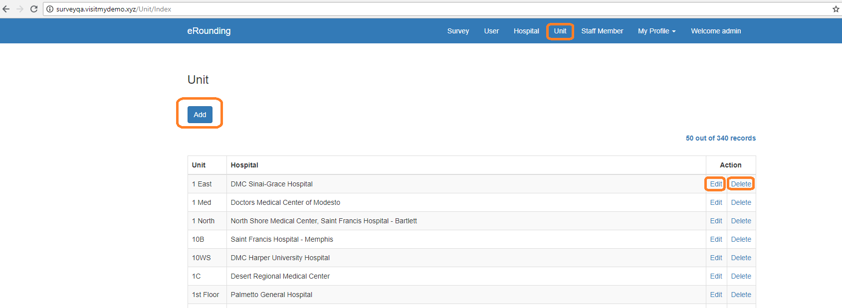

1. On Add Unit page admin can add multiple hospitals for one unit.

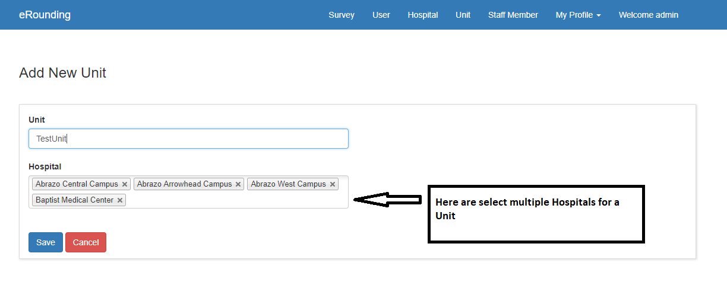

1. On Edit Unit page, admin can edit unit name and add/remove hospital selection.

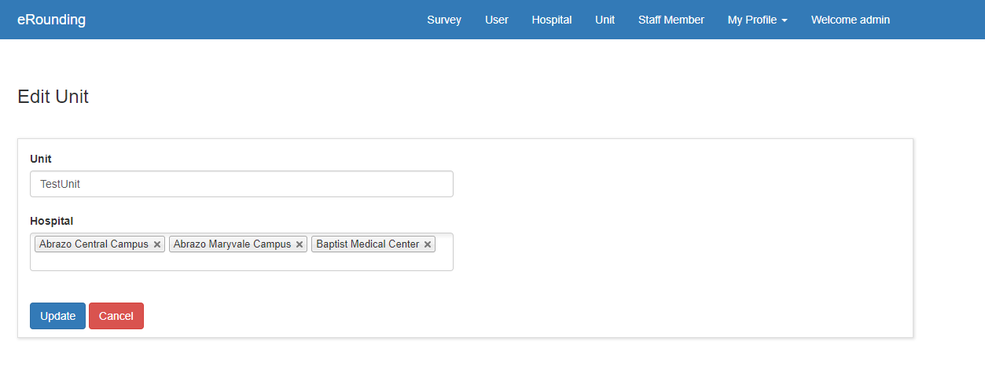

## **For Hospital Admin:**

1. Hospital admin can Add and Edit unit only, Hospital admin cannot able to delete units.

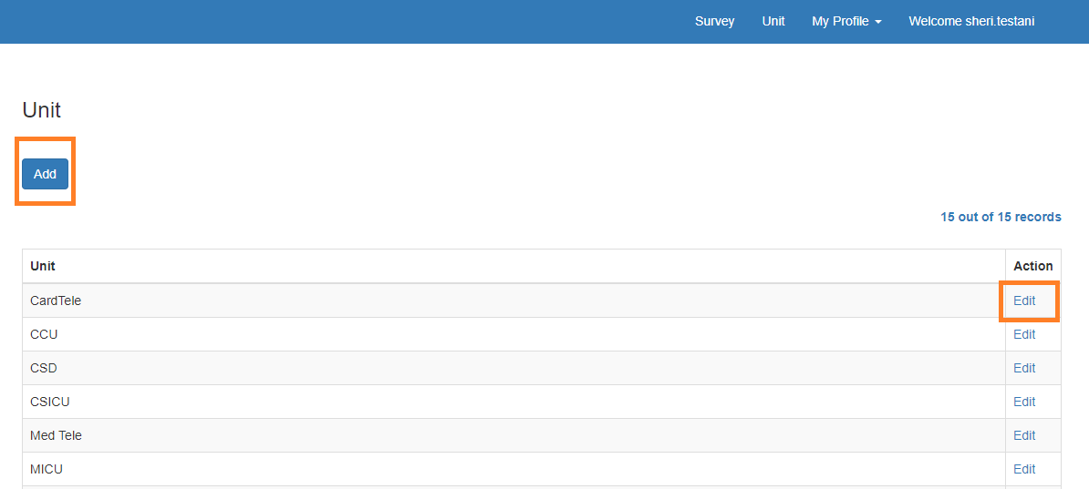

1. On Add Unit page, Hospital admin can add unit for own hospital only. Hospital admin cannot change hospital because hospital field is read only.

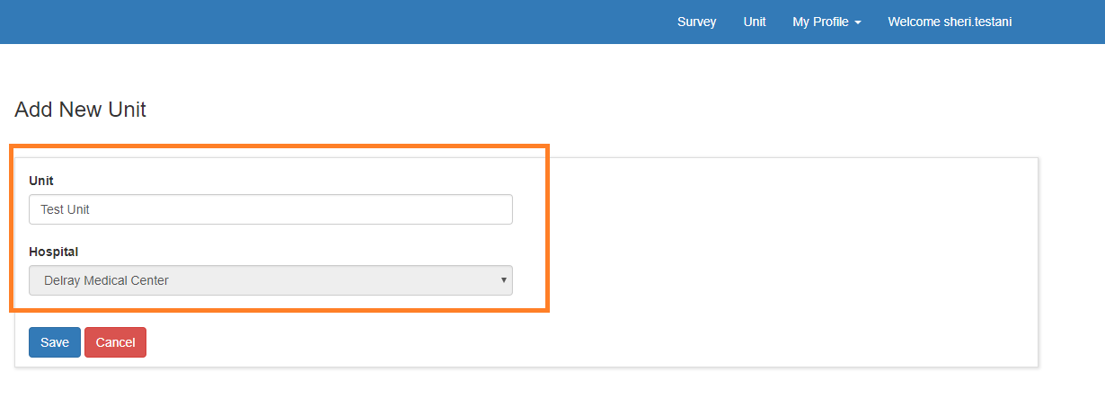

1. On Edit unit page. Hospital admin can change only unit name, cannot hospital name because hospital field is read only.

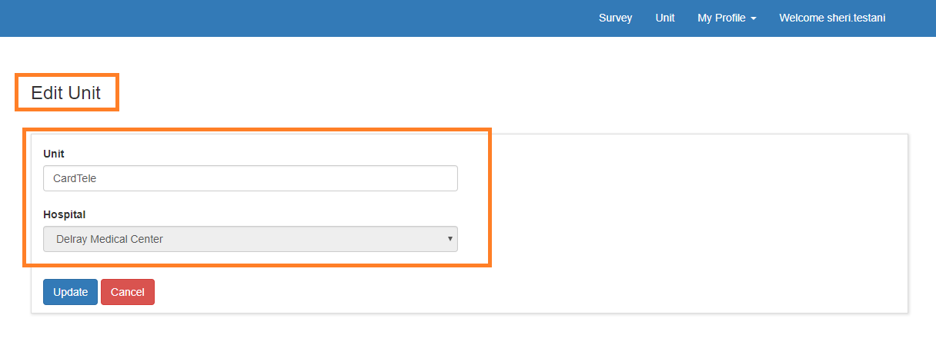

## **For Project Sponsor**

1. Project Sponsor user role cannot see Unit menu.